Project Report
on
QNX RTOS-Based Secured Communication Gateway for Autonomous Vehicles

Submitted in the partial fulfilment of the requirements for
the award of the degree of

BACHELOR OF TECHNOLOGY
In
ELECTRONICS AND COMMUNICATION ENGINEERING
By

A. N. S. L. REVATHI 22311A04EC

UNDER THE GUIDANCE OF
Dr. S.K. Satyanarayana Dr. Mallikarjun Mudda
Assistant Professor Associate Professor



DEPARTMENT OF ELECTRONICS & COMMUNICATION ENGINEERING
SREENIDHI INSTITUTE OF SCIENCE AND TECHNOLOGY
(Autonomous)
Yamnampet (V), Ghatkesar (M), Hyderabad – 501 301.
April 2026

SREENIDHI INSTITUTE OF SCIENCE AND TECHNOLOGY
(Affiliated to Jawaharlal Nehru Technological University, Hyderabad)
Yamnampet (V), Ghatkesar (M), Hyderabad – 501 301
Department of Electronics and Communication Engineering
CERTIFICATE
This is to certify that the project report entitled “QNX RTOS-Based Secured Communication Gateway for Autonomous Vehicles” is being submitted by

A. N. S. L. REVATHI 22311A04EC

in partial fulfilment of the requirements for the award of Bachelor of Technology degree in Electronics and Communication Engineering to Sreenidhi Institute of Science and Technology affiliated to Jawaharlal Nehru Technological University, Hyderabad (Telangana). This record is a bona fide work carried out by them under our guidance and supervision. The results embodied in the report have not been submitted to any other University or Institution for the award of any Degree or Diploma.

Dr. S.K. Satyanarayana Dr. Mallikarjun Mudda
Assistant Professor Associate Professor

Head of the Department
Dr. S.P.V. SUBBA RAO
Professor, Department of ECE

Signature of the External Examiner
ACKNOWLEDGMENT
We want to express our sincere gratitude to our guide Dr. S. K. Satyanarayana, Assistant Professor, for his constant guidance, technical expertise, and constructive feedback during both the project development and publication process, which greatly enhanced the quality of our work and helped us successfully carry out our Major Project titled “QNX Based Secure Gateway Communication for Autonomous Vehicles.” We are deeply grateful to our project coordinator, Dr. Mallikarjun Mudda, Associate professor ,for his support and valuable inputs throughout the execution of this project.
We extend our heartfelt thanks to our Head of the Department, Dr. S. P. V. Subba Reddy, for his valuable guidance, continuous support, and for fostering a disciplined and intellectually enriching academic atmosphere. His encouragement and insightful suggestions have significantly contributed to the successful completion of this project.
We are deeply grateful to our respected Principal, Dr. T. Ch. Siva Reddy, for his visionary leadership and for providing a supportive academic environment that enabled us to successfully carry out our major project. His encouragement towards innovation, research, and technical excellence has been a constant source of motivation throughout the development of this work. We also extend our sincere thanks to Prasad Sir for his guidance, encouragement, and valuable suggestions.
Finally, we would like to thank all the faculty members and staff of the department for their cooperation and support. We also express our heartfelt gratitude to our friends and family members for their encouragement and moral support throughout the course of this project. This project work has been carried out by:

A. N. S. L. REVATHI 22311A04EC
under the guidance of
Dr. S.K. Satyanarayana, Assistant Professor

DECLARATION

We hereby declare that the work described in this thesis titled “QNX-Based Secured Communication Gateway for Autonomous Vehicles” which is being submitted by us in partial fulfilment for the award of Bachelor of Technology in the Department of Electronics and Communication Engineering, Sreenidhi Institute Of Science and Technology is the result of investigations carried out by us under the guidance of Dr. S.k. Satyanarayana, Assistant Professor, Department of ECE, Sreenidhi Institute of Science and Technology, Hyderabad.

No part of the thesis is copied from books/ journals/ internet and whenever the portion is taken, the same has been duly referred. The report is based on the project work done entirely by us and not copied from any other source. The work is original and has not been submitted for any Degree/Diploma of this or any other University.

Place: Hyderabad
Date:

A. N. S. L. REVATHI 22311A04EC

TABLE OF CONTENTS
Section No. | Description | Page No.
Abstract |  | 1
CHAPTER1: INTRODUCTION
1.1 | Motivation | 2
1.2 | Problem statement | 2
1.3 | Objective | 3
1.4 | Scope of the Project | 3
1.4 | Main Contribution | 4
1.5 | Organization of thesis | 5
CHAPTER 2: LITERATURE SURVEY
2.1 | Introduction to Autonomous Vehicles | 7
2.2 | Vehicular Communication Protocols | 7
2.3 | Security challenges in Autonomous Vehicle Networks | 8
2.4 | QNX RTOS in Automotive Systems | 9
2.5 | Establishment of Communication between Autonomous Vehicles | 10
CHAPTER 3: SYSTEM ARCHITECTURE AND DESIGN
3.1 | Overall System Overview | 11
3.2 | QNX RTOS Architecture | 11
3.2.1 | QNX Microkernel Architecture | 12
3.2.2 | Process Management | 13
3.2.3 | Message Passing Mechanism | 14
3.3 | Proposed Client-Server Architecture | 15
3.4 | Raspberry Pi as Vehicle Node | 15
3.5 | Client-Server System | 15
3.6 | Communication Mechanism | 16
3.7 | Block Diagram | 17
3.8 | Data Flow Diagram | 18
CHAPTER 4: HARDWARE AND SOFTWARE COMPONENTS
4.1 | QNX Operating System | 19
4.2 | Raspberry Pi Board | 20
4.3 | Sensors | 22
4.3.1 | Ultrasonic Sensor | 22
4.3.2 | IR Sensor | 22
4.4 | RJ45 Ethernet Adapter | 23
4.5 | Ethernet Switch | 24
4.6 | Development ID’s | 25
CHAPTER 5: SYSTEM IMPLEMENTATION AND PROGRAM DEVELOPMENT
5.1 | Design Approach | 27
5.2 | QNX Deployment on Raspberry Pi | 27
5.2.1 | Technical Installation of QNX Neutrino RTOS on Raspberry Pi | 28
5.3 | Hardware Integration | 33
5.3.1 | Procedure for Hardware Setup | 33
5.4 | Network Setup | 34
5.4.1 | Setting up the Network Configurations | 34
5.5 | QNX Target Setup and GPIO Access | 36
5.6 | Code Structure and Design | 40
5.6.1 | Make File | 40
5.6.2 | Server Code | 41
5.6.3 | Client Code | 46
5.7 | System Integration Process | 49
CHAPTER 6: TESTING AND VALIDATION
6.1 | Test Plan Design | 51
6.2 | Functional Verification | 51
6.3 | Communication Reliability Testing | 52
CHAPTER 7: RESULTS AND DISCUSSIONS
7.1 | Experimental Output Analysis | 54
7.2 | Performance Evaluation | 56
7.3 | Observational Study | 58
7.4 | Comparative Analysis | 59
CHAPTER 8: FUTURE SCOPE AND CONCLUSION
8.1 | Scope for Enhancement | 60
8.2 | System Improvements | 60
8.3 | Summary of Contributions | 61
8.4 | Final Remarks | 62
AUTHOR’s PUBLICATION
REFERENCES
ENCLOSED PLAGIARISM REPORT

LIST OF FIGURES
Figure No. | Description | Page No.
Figure 3.1 | Microkernel Design | 12
Figure 3.2 | Process Manager | 13
Figure 3.3 | Block Diagram | 17
Figure 3.4 | Data Flow Diagram | 18
Figure 4.1 | QNX Microkernel Design | 20
Figure 4.2 | Raspberry Pi Board | 21
Figure 4.3 | Ultrasonic Sensor | 22
Figure 4.4 | IR Sensor | 23
Figure 4.5 | RJ45 Ethernet Adapter | 24
Figure 4.6 | Ethernet Switch | 25
Figure 5.1 | Hardware Setup | 50
Figure 7.1 | Console Output | 54
Figure 7.2 | Output Instance 1 | 55
Figure 7.3 | Output Instance 2 | 55
Figure 7.4 | Output Instance 3 | 55
Figure 7.5 | Latency Graph | 56
Figure 7.6 | Data Accuracy Graph | 57

ABSTARCT
The evolution of autonomous vehicles has rapidly increased which depends on real-time communication between Electronic Control Units (ECUs). However real-time high integrity communication also introduces cyber security threats and data tampering. To deal with these challenges, this project delivers implementation of QNX RTOS-based Secured Communication Gateway for Autonomous Vehicles.
The model utilizes QNX Neutrino Real Time Operating System (RTOS). Since this project mainly focuses on secure and delay-critical communication, QNX Neutrino helps in ensuring deterministic real-time behaviour along with safety-certified applications through its microkernel architecture. The gateway serves as the centralized secure interface, which handles communication between inter-vehicle networks and external vehicle-to-everything (V2X). To enhance the data confidentiality, integrity and availability, security features like secure boot, authentication and encryption support are integrated.
For the system to be fault-tolerant and less risky, the architecture is designed in a scalable way, which enables isolation of critical safety functions from non-critical services. The performance testing demonstrates that the gateway continues to maintain its deterministic real-time response while applying all security rules, which makes it suitable for autonomous vehicles. The combination of QNX RTOS and secure gateway architecture fundamentally enhances the cyber resilience for future autonomous vehicles. The system has to be flexible with each component of modular design, such as communication handling, security services and monitoring modules that operate independently. This separation of each component ensures that they do not affect safety-critical vehicle operations. By sandboxing the processes at the operating system level, the reliability and the failure of the whole system is reduced. Altogether, this system provides reliable, scaled secure structure for autonomous vehicles.

CHAPTER 1: INTRODUCTION

  - MOTIVATION
The development of autonomous vehicle technology has revolutionized transportation, relying heavily on seamless communication between internal sensors, controllers, and external systems for real-time navigation and monitoring[1]. As these vehicles become increasingly connected to external networks, they face significant security risks, including cyber-attacks and data spoofing, which can threaten passenger safety[2]. Consequently, establishing secure and reliable communication channels is critical for the deployment of autonomous systems.
To tackle these security vulnerabilities, a secure gateway serves as a vital component to protect data exchange between the vehicle's internal network and external infrastructure. This project addresses these risks by implementing a secure communication gateway designed to prevent attacks through robust encryption and authentication techniques[3]. Autonomous vehicles require secure communication systems [1]. Specifically, the system utilizes Raspberry Pi boards as vehicle nodes and a laptop as a server, enabling secure, seamless communication between the client and the server.
  - PROBLEM STATEMENT
The working of Autonomous vehicles depends on crucial communication between internal components and external entities. Existing communication techniques are highly exposed to cyber threats, as multiple systems fail to provide strong security, efficient authentication mechanisms, and secure routing control. From these disadvantages, attackers can perform activities like:
- Man-in-the-middle-attacks
- Message spoofing
- Unauthorized access
- Denial of service (DOS) attack
Vehicle performance and passenger safety will be at risk due to these vulnerabilities. Cyber intrusion will be easier if there is no secured gateway for internal and external data exchange activities, which directly compromises safety. Accordingly, the problem this project focuses on is the lack of a secured gateway for communication—specifically between a single vehicle's internal nodes and external networks (Raspberry Pi acting as a client to a server)—which is capable of filtering, encrypting, and authenticating data. The ultimate solution for these drawbacks is an efficient, deterministic operating system that can handle real-time communication along with robust security mechanisms.
  - OBJECTIVE
The primary objective of this project is to design and implement a QNX-based secured communication gateway to guarantee secure, authorized and accurate data exchange within vehicle networks. These networks manage data from components like sensors, navigation modules, braking systems and control units. Any delay or unauthorized access in the communication between these modules could result in incorrect vehicle responses, significantly increasing the risk of accidents. Therefore, building an effective secured gateway for controlling and managing communication between these components is the main objective of this project.
The core part of the project is executed by setting up a QNX Neutrino RTOS Development Environment and booting the Raspberry Pi. QNX Neutrino RTOS is a true microkernel operating system where every application runs outside the kernel in the safety of memory protected user space. A network simulation module is used to handle the communication network, with the Raspberry Pi acting as a client and a laptop as a server to facilitate secure data exchange. This setup ensures the system can react effectively based on processed data within a single vehicle's architecture.

  - SCOPE OF THE PROJECT
This project implements the QNX Neutrino RTOS on Raspberry Pi hardware to create a secure, deterministic vehicle node for Vehicle-to-Vehicle (V2V) communication. The system collects real-time sensor data—including distance, speed, and environmental conditions—which is processed locally for instant decision-making. The core focus is on utilizing QNX's multitasking capabilities to read, process, and act upon sensor input from neighboring vehicles, improving intelligent transportation systems and reducing latency.
Within the scope of this project, robust, multi-layered security architecture is implemented to ensure the integrity and confidentiality of vehicular sensor data. The project focuses on developing a specialized secure gateway that acts as the primary defence mechanism between in-vehicle nodes and external interfaces. At its core, the system implements advanced secure message routing protocols, ensuring that sensor data is transmitted through authenticated channels and encrypted using modern, lightweight cryptographic techniques to prevent eavesdropping and unauthorized data manipulation.
The implementation is limited to a prototype that demonstrates communication between nodes by analysing the condition near the vehicle. This execution proves the feasibility of integrating with an AI-based intrusion detection system and real-time vehicle integration. My main motive is to receive data from cars through sensors and read that data, ensuring direct node communication without external navigation or global positioning systems. The prototype focuses on sensor-driven data ingestion for anomaly detection within a controlled environment. This approach validates the integration of on-board sensor data with AI models to identify potential security threats, focusing entirely on internal node communication.

1.5 MAIN CONTRIBUTIONS
The primary contribution of this project is to deliver a secure, real-time communication gateway between a Raspberry Pi (acting as a client) and a laptop (acting as a server), leveraging the QNX Neutrino RTOS system to ensure high reliability and safety. Utilizing the minimalist QNX microkernel, which prioritizes processes and utilizes message passing, the system guarantees robust, real-time data exchange. Furthermore, data confidentiality and integrity are ensured through integrated secure authentication, encryption mechanisms, and packet filtering techniques between the designated client-server pair.
A key contribution of this project is the utilization of the GNS3 network simulator to model secure vehicular network architecture. The design simulates a gateway-based system protecting communication between a Raspberry Pi (acting as a vehicle node) and a laptop (acting as a server). By validating the security of data exchange between these client-server nodes in real-time scenarios, the architecture prevents malicious packets, unauthorized access, and network attacks from compromising vehicle systems. This work contributes to cyber security research by enhancing operational safety in autonomous vehicle environments.
  - ORGANIZATION OF THE THESIS
The thesis is structured as follows:
CHAPTER 1: INTRODUCTION - This chapter explain about the background, motivation to build the project, problem statement, objectives, and scope of the project. It explains the requirement of building the project especially using QNX RTOS.
CHAPTER 2: LITERATURE SURVEY – This section provides an overview of autonomous vehicles, relevant vehicular protocols, and the critical security challenges associated with their operational frameworks.
CHAPTER 3: SYSTEM ARCHITECTURE AND DESIGN – This section details the software utilized, the system development approach, and the flow diagram for system execution.
CHAPTER 4: HARDWARE AND SOFTWARE COMPONENTS – This chapter explains the functions of hardware components, their integration into the system, and how they interface with software to enable overall system operation.
CHAPTER 5: SYSTEM IMPLEMENTATION AND PROGRAM DEVELOPMENT – The implementation section outlines the step-by-step procedure for executing the project, running the code, and observing the results.
CHAPTER 6: TESTING AND VALIDATION – This chapter details the testing of every system component to ensure efficient, reliable, and stable output.
CHAPTER 7: RESULTS AND DISCUSSIONS - This chapter presents the results of the proposed system, followed by a detailed analysis of the output and an exploration of potential future enhancements.
CHAPTER 8: FUTURE SCOPE AND CONCLUSION – The final chapter presents the conclusion, outlines potential future improvements, and highlights the enhancements implemented to enhance system performance.

CHAPTER 2: LITERATURE SURVEY

2.1 INTRODUCTION TO AUTONOMOUS VEHICLES
Autonomous vehicles are self-driving systems that can manage all driving operations without human involvement. Autonomous vehicles rely on sensors and AI for decision making [1].They manage driving activity by sensing the environment, identifying obstacles, observing traffic signals, and navigating. The combination of technologies involved includes sensors, cameras, radars, LIDAR, GPS, and artificial intelligence to make correct decisions. By continuously collecting real-time data, they detect obstacles, interpret traffic signals, monitor road conditions, and navigate to the destination safely.
The primary goal of developing autonomous vehicles is to improve safety by preventing road accidents. Human errors, such as driver fatigue, lack of skill, and poor decision-making, are increasing daily. To mitigate these risks, autonomous vehicles are introduced to make quick decisions and continuously monitor road conditions. Furthermore, many accidents occur due to high speeds, brake failures, or a poor understanding of traffic rules. With the use of sensors that collect real-time data, this technology assists in stopping at traffic signals, adjusting speed based on the surrounding environment, and adhering to traffic rules, thereby reducing accidents.
2.2 VEHICULAR COMMUNICATION PROTOCOLS
Vehicular protocol communication enables autonomous vehicles to exchange data with other vehicles, road side infrastructure, and external networks. Communication helps in reading the other vehicles speed, location, break status etc., by sharing the data with other vehicles or other infrastructure. Vehicular communication protocols such as V2V and V2X are widely used [2]. Communication will be different types they are Vehicle-to-Vehicle (V2V), Vehicle-to-Infrastructure (V2I), and Vehicle-to-Everything (V2X).
Vehicle-to-Vehicle (V2V) communication involves secure data exchange between neighbouring vehicles. Through V2V, exchanged data includes lane changes, speed, and hazardous conditions. This real-time data exchange helps vehicles respond quickly and act accordingly. V2V communication increases situational awareness and supports applications like collision avoidance systems and cooperative adaptive cruise control.
Vehicle-to-Infrastructure (V2I) communication enables vehicles to interact with roadside infrastructure, such as toll systems, traffic signals, and road sensors. Using information from the infrastructure, a vehicle can manage its speed to reach its destination efficiently or change its route if a construction zone is detected. This communication effectively improves the traffic system, reduces fuel consumption, saves time, and supports the development of a smart city transportation system.
Vehicle-to-Everything (V2X) communication is a comprehensive system that integrates V2V, V2I, Vehicle-to-Pedestrian (V2P), and Vehicle-to-Network (V2N) communication. Utilizing V2X, vehicles not only communicate with other vehicles or roadside infrastructure but also with cloud services and external networks. Since V2X involves connecting with broader elements, securing the data and communication becomes critically important. Therefore, in this project, V2X is used to communicate with every component via a gateway.
2.3 SECURITY CHALLENGES IN AUTONOMOUS VEHICLE NETWORKS
The effectiveness of autonomous vehicles depends on continuous, real-time data exchange between internal and external networks. Since autonomous vehicles operate based on real-time sensor data and communication messages, any obstruction in this process jeopardizes vehicle and passenger safety. The integration of cloud connectivity, wireless communication, and multiple ECUs expands the attack surface. Therefore, ensuring data integrity, confidentiality, and security is a major challenge.
Some of the major issues include message spoofing and unauthorized access to data. Incorrect driving decisions may occur when attackers attempt to inject false information into the network, such as incorrect traffic updates or wrong collision data. A man-in-the-middle attack is another significant issue, where attackers attempt to intercept communication between two vehicles, potentially causing accidents. Cyber security threats like spoofing and DoS attacks are major concerns [3]. Additionally, Denial-of-Service (DoS) attacks can cause total communication failure by overwhelming the network with excessive traffic or causing delays. Since autonomous vehicles depend on low-latency communication, even a small communication issue can cause total disruption of the vehicle system.
Another notable challenge is ensuring authentication and data privacy in large-scale V2X communication. Strong encryption, secure key management, and robust authentication are crucial, as vehicles continuously share sensitive data, such as location, speed, and travel routes. Because the gateway connects the internal vehicle network to external networks, protecting and securing it is paramount.
One of the major security challenges in in-vehicle-Ethernet networks is unauthorized access and data spoofing. Attackers can inject false information into the Ethernet stream such as fake diagnostic trouble codes, manipulated sensor readings, or false firmware updates, which can lead to incorrect analysis or safety critical decisions by electronic control units.
Another noteworthy challenge in today’s automotive equipment is ensuring data privacy and authentication while using Ethernet-based data exchange between vehicles and laptops. Real-time vehicle data—such as ECU status, location, and speed—need to be protected from unauthorized access and tampering as they pass through the Ethernet gateway. To prevent tampering with this real-time data, it is essential to implement robust security mechanisms, including MAC security for Ethernet frames and strong device authentication for connected laptops.
2.4 QNX RTOS IN AUTOMOTIVE SYSTEMS
QNX RTOS is an extensively adopted operating system, famous for its reliability, security, and real-time operating capabilities QNX RTOS is widely used in automotive systems due to its microkernel architecture [4]. QNX RTOS is widely trusted because of its microkernel architecture: crucial tasks—such as scheduling, inter-process communication, and interrupt handling—are carried out in the kernel, while all other processes operate in user space. This system stability and fault isolation ensure that a failure in one component does not lead to a total system shutdown. Such reliability is crucial in applications where safety and precision are paramount, allowing QNX to play a major role in the automotive industry.
QNX Neutrino is a real-time, microkernel-based operating system designed for reliability, scalability, and fault tolerance. Its modular architecture ensures system robustness through independent components. The microkernel handles only the essential services such as inter process communication (IPC), thread scheduling, and interrupt handling. Other components like file systems, device drivers, and protocol stacks run as separate user-space processes known as resource managers. This design minimizes kernel complexity and improves system resilience.
A vital advantage of QNX RTOS in automotive systems is its strong security framework, which supports secure boot mechanisms, memory protection, and process isolation to prevent unauthorized access and cyber-attacks. In this project, QNX acts as the core platform for critical tasks, such as receiving data and acting upon it in real-time. By leveraging its real-time performance and built-in security features, the QNX software—running on both a laptop and a Raspberry Pi—functions in a safety-critical manner via Ethernet, contributing to proper vehicle guidance.
2.5 ESTABLISHMENT OF COMMUNICATION BETWEEN AUTONOMOUS VEHICLES
The primary goal of this project is to establish a reliable, wired Ethernet-based communication system for data exchange between autonomous vehicle nodes. Each vehicle is represented by a Raspberry Pi module integrated with sensors, while connected laptops function as central processing units. All components, including the Raspberry Pi’s and laptops, connect via an Ethernet switch to facilitate data exchange. Each node is assigned a unique IP address within the same subnet to ensure seamless, robust communication.
The communication process begins by collecting data from sensors connected to a Raspberry Pi. Laptops acting as servers receive, process, and manage this data, which is then exchanged between vehicles via an Ethernet switch. Ethernet-based communication ensures reliable data exchange [5].This setup ensures low latency, high reliability, and secure transmission. The data between client and server is exchanged using a client-server mechanism which ensures efficient data handling and scalability for adding more vehicle nodes in the future.

CHAPTER 3: SYSTEM ARCHITECTURE AND DESIGN

3.1 OVERALL SYSTEM OVERVIEW
The proposed system controls vehicles and establishes communication between them to prevent accidents. The architecture integrates vehicle nodes and a simulated communication network environment. Raspberry Pi nodes are configured as vehicle nodes, representing electronic control units and sensor modules, while communication is established to exchange real-time data. The core part of this project is the QNX RTOS, which operates as a secured platform, ensuring efficient real-time data processing and controlled communication between internal and external systems.
Data generated from vehicle nodes—such as speed, location, braking status, and roadside infrastructure information—is transmitted to servers and other nodes via V2X networks. This data is first passed through a QNX-secured gateway. To ensure data safety, the gateway performs message encryption and decryption, device authentication, packet filtering, and access control[3]. Through this mechanism, it ensures that only trusted and authorized data enters the vehicle network.
The overall architecture follows a layered approach where the internal vehicle network is secluded from external communication channels through a secure gateway. This isolation ensures the safety of the data and prevents external threats. To prevent accidents in autonomous vehicles, this structured and secured communication framework enhances real-time decision-making, prevents malicious attacks, and contributes to safe travel.
3.2 QNX RTOS ARCHITECTURE
The QNX real-time operating system (RTOS) follows a microkernel architecture, which is especially designed to provide reliability, security, and deterministic real-time performance[9]. Unlike all other traditional operating systems where all the processes run in the kernel, QNX runs core functions such as inter-process communication, thread scheduling, and interrupt handling. All remaining minor core functions will be running in user space. This mechanism ensures quick responses and improves the stability of the proposed system. It uses priority-based pre-emptive scheduling to ensure high-priority tasks, such as braking or steering control commands, are executed without any delay. This operating system supports memory protection and process isolation by preventing unauthorized access between system components. Communication between processes is handled using a secure message-passing mechanism, which ensures controlled and predictable data exchange.
3.2.1 QNX MICROKERNEL ARCHITECTURE
The core of QNX Neutrino is its microkernel, which performs only the most critical functions:
- Thread scheduling
- Inter-process communication (IPC)
- Interrupt handling
All other functions — device drivers, file systems, and networking stacks — execute as separate user-space processes known as resource managers. This design minimizes kernel complexity and enhances reliability since user-space failures do not crash the kernel.
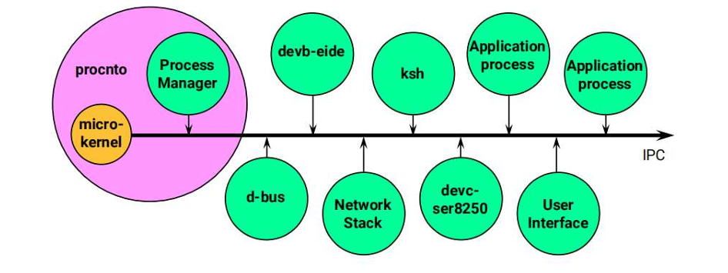
Figure 3.1 Microkernel Design
Advantages of microkernel architecture are
1. Fault Isolation: If a driver or file system crashes, the kernel and other processes remain unaffected.
2. Modularity: Developers can replace or update components without rebooting the system.
3. Security: Each component runs with limited privileges.
4. Scalability: Supports systems ranging from small embedded boards to multi-core servers.
Owing to these advantages, the QNX RTOS architecture is the most stable, reliable, and secured operating system.
The architecture of QNX Microkernel is illustrated in Figure 3.1
3.2.2 PROCESS MANAGEMENT
A process in QNX represents an independent program running in its own protected memory space. Each process has its own virtual address space, file descriptors, and system resources. This isolation ensures that one process cannot corrupt or interfere with another process’s data or execution.
Key Characteristics:
- Own address space (protected memory).
- Contains one or more threads.
- Independent execution and termination.
- Interacts with other processes via Inter process Communication (IPC).
- Managed by the Process Manager (procnto).
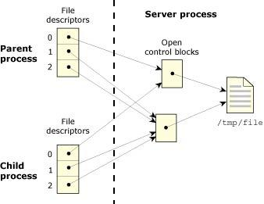
Figure 3.2 Process Manager
Process management in QNX RTOS is modelled to provide reliable and deterministic execution of tasks in real-time automotive systems. Each system service runs as an independent process with its own protected memory space, ensuring stability and controlled operation. QNX follows priority-based pre-emptive scheduling where critical tasks will be executed immediately when required.
The process management structure is shown in Figure 3.2
Key features of process management in QNX include:
- Priority-based pre-emptive scheduling for real-time task execution
- Independent process execution with separate memory spaces
- Fast context switching for efficient multitasking
- Support for multithreading within processes
3.2.3 MESSAGE PASSING MECHANISM
The core feature of microkernel architecture is communication between processes which is achieved through message passing mechanism. QNX uses structured message exchange to ensure secure and controlled communication, instead of allowing process to directly share memory. Message passing mechanism helps in exchanging data in real-time from components like sensors, control units, and gateway modules. The message passing mechanism operates using a client-server model, where one process sends a request (message) and other process responds accordingly. This methodical communication provides synchronization and data integrity during interaction.
Key characteristics of the QNX message passing mechanism include:
- Client-server communication model for structured interaction
- Synchronous and asynchronous message exchange
- Secure inter-process communication (IPC)[9]
- Priority inheritance to avoid priority inversion problems
- Deterministic response time for real-time operations
3.3 PROPOSED CLIENT SERVER ARCHITECTURE
The system operates on a client-server model: the Raspberry Pi acts as the client, and a QNX-based laptop acts as the server. Sensors connected to the Raspberry Pi collect real-time data, which the client then sends to the server. The client initiates this communication once the data is ready, while the server continuously monitors for and receives this data.
The server processes data and determines the actions to be followed by the client based on satisfied conditions. This architecture ensures centralized decision-making while maintaining distributed data collection[1]. The client-server model simplifies design, enhances stability, and allows multiple clients to communicate with a single server.
3.4 RASPBERRY PI AS VEHICLE NODE
The Raspberry Pi board is used as a vehicle node to represent electronic control units (ECUs) and sensor modules which are attached to the autonomous vehicles. The data is generated from the vehicles such as breaking status, speed, warning signals and this data is exchanged within the network. Due to its pocket-size, processing capability, and network support, Raspberry pi serves as a cost effective platform for simulating real-time vehicular communication.
Each Raspberry Pi node is connected to network using Ethernet and communicates with other Raspberry Pi using Ethernet switch. Using the Ethernet the data is transmitted to the QNX gateway for authentication, encryption, and filtering before reaching other nodes. This configuration allows easier testing of communication performance and security of real-time data without using actual vehicle hardware.
3.5 CENTRAL SERVER SYSTEM (LAPTOP)
The laptop acts as a central server for its own vehicle node and runs the QNX Real-Time Operating System. The responsibility of this central server is to continuously receive data from clients and respond to them after processing the data. QNX is chosen due to its reliability and stability, enabling it to run critical operations—such as data processing and decision-making—within strict time constraints. The server maintains continuous communication with the clients and provides immediate responses, which is crucial for safety-critical applications such as vehicle control.
3.6 COMMUNICATION MECHANISM (ETHERNET-BASED)
The communication mechanism is established using a wired Ethernet network where all devices from two vehicles are interconnected through a central switch. The proposed system consists of two Raspberry Pi-based vehicle nodes and two laptop systems, with each device assigned a unique IP address within the same subnet. The Raspberry Pi nodes have different IP addresses, and the laptops have different IP addresses. With these distinct IP addresses, each device can be uniquely identified and can participate in the network communication without conflicts.
Data is transmitted in the form of packets between all connected devices with the help of an Ethernet switch, which acts as a central communication hub. When a vehicle node generates real-time data, it is transmitted over the Ethernet network in packets. The Ethernet switch forwards these data packets to the destination—another Raspberry Pi vehicle—based on the IP address. The switch facilitates both direct and indirect communication between the Raspberry Pi nodes. Direct communication can occur through a laptop acting as a server, while indirect communication is facilitated through a structured data exchange mechanism. The use of an Ethernet network in this system ensures high reliability, low latency, and reduced packet loss, making it suitable for real-time vehicle communication[12].
3.7 BLOCK DIAGRAM
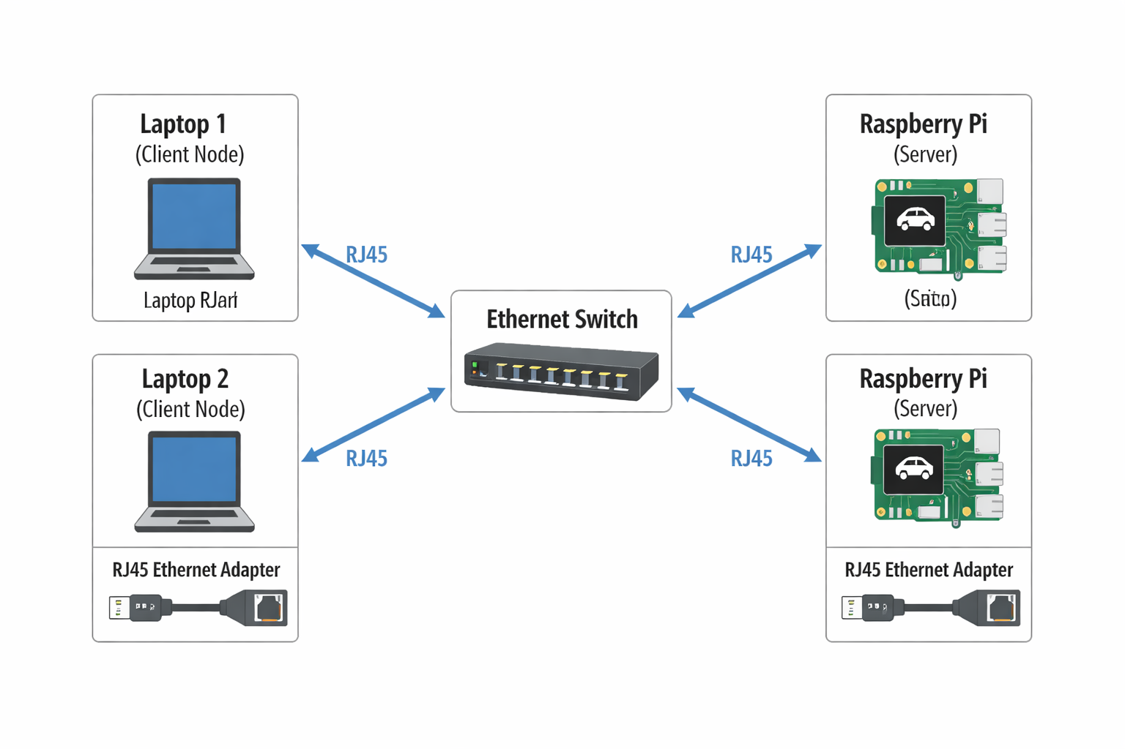The overall system architecture is represented in block diagram as shown in figure 3.3
Figure 3.3 Block Diagram
3.8 DATA FLOW DIAGRAM
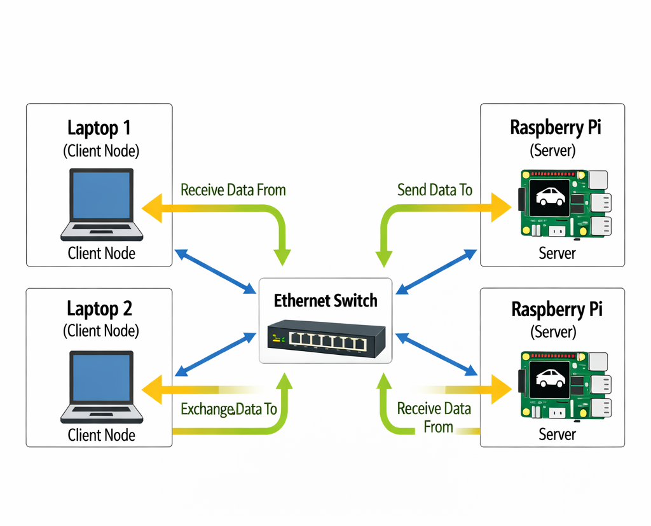
The data movement between system components is illustrated in figure 3.4

Figure 3.4 Data Flow Diagram

CHAPTER 4: HARDWARE AND SOFTWARE COMPONENTS

4.1 QNX OPERATING SYSTEM
QNX Neutrino is a real-time, microkernel-based operating system designed for reliability, scalability, and fault tolerance. Its modular architecture ensures system robustness through independent components. The microkernel handles only the essential services such as inter-process communication (IPC), thread scheduling, and interrupt handling. Other components like file systems, device drivers, and protocol stacks run as separate user-space processes known as resource managers. This design minimizes kernel complexity and improves system resilience.
Key Features:
- Microkernel-based architecture
- POSIX compliance
- Message-passing IPC mechanism
- Fault isolation through process separation
- Real-time performance guarantees
QNX’s architecture is highly suitable for embedded and mission-critical applications like automotive ECUs, medical devices, and industrial control systems.
The architecture is shown in Figure 4.1
In this project, the QNX Operating System serves as the core platform for implementing secured communication between autonomous vehicles. It handles authentication, encryption, and message routing while maintaining real-time performance. Through inter-process communication, pre-emptive priority scheduling, and process isolation, the system achieves higher reliability and security. QNX enhances communication and passenger safety with its microkernel architecture. Because the QNX OS is specifically designed for safety-critical systems—such as automotive vehicles, industrial automation, and medical devices—it is an exceptionally efficient and specialized choice[9]. This unique operating system provides advanced features that ensure greater safety.

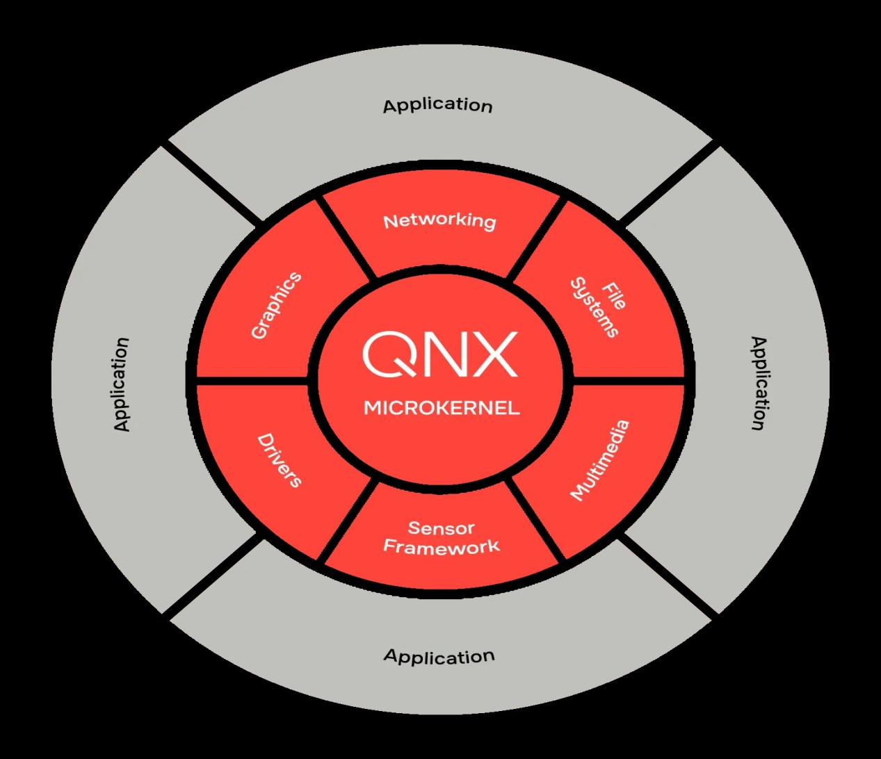
Figure 4.1 QNX Microkernel Design
4.2 RASPBERRY PI BOARD
The Raspberry Pi board is a small single-board computer extensively used for embedded systems, IOT applications, and network-based projects[13]. In spite of its compact size, it is capable of running a full operating system and able to perform real time communication tasks. The major parts of Raspberry Pi board are Broadcom BCM2711 processor, RAM, USB ports, HDMI output, Ethernet/Wi-Fi connectivity, and a 40-pin General Purpose Input / Output (GPIO) header. In this project, the Raspberry Pi acts as a vehicle node, generating and transmitting data within the simulated V2X network. The most important hardware part of the Raspberry Pi is its 40-pin GPIO header, which allows interaction with external devices such as sensors, actuators, and communication modules. The GPIO pins are listed as below:
- Power Pins (5V, 3.3V, GND) – Provide power supply to external components.
- GPIO Pins – Configurable pins used for digital input and output operations.
- UART Pins (TX, RX) – Used for serial communication between devices.
- I2C Pins (SDA, SCL) – Enable communication with sensors and peripheral modules.
- SPI Pins (MOSI, MISO, SCLK, CE) – Support high-speed communication with external devices.
- PWM Pins – Used for controlling motors and actuators.
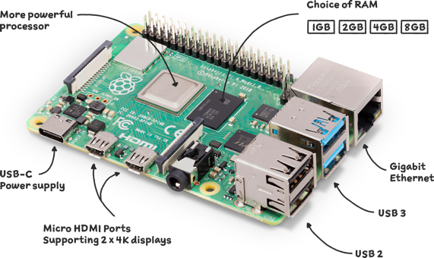
Figure 4.2 Raspberry Pi Board
These GPIO pins allow the Raspberry Pi board to read the data such as speed, distance, or breaking signals by inetrfacing with sensors. The GPIO and communication pins enable the Raspberry Pi to act as a vehicle control unit. This hardware flexibility makes it suitable for building and testing autonomous vehicle communication systems in a prototype environment.
The hardware structure and their uses is shown in Figure 4.2
4.3 SENSORS
4.3.1 ULTRASONIC SENSOR
An ultrasonic sensor is an electronic device that measures the distance to an object by emitting high-frequency sound waves and measuring the time it takes for the echo to reflect back.
- Transmission: The sensor emits an ultrasonic sound pulse through a transmitter.
- Reflection: The sound wave hits an object and bounces back.
- Reception: A receiver on the sensor detects the reflected wave.
- Calculation: The sensor calculates the distance using the time taken for the echo to return:
Distance=Time × Speed of Sound/2
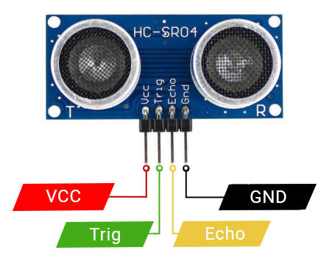
Figure 4.3 Ultrasonic Sensor
The Ultrasonic sensor pins and their work is shown in Figure 4.3
4.3.2 INFRARED SENSOR
An Infrared Sensor is an electronic device that emits or detects infrared radiation to sense surroundings, measure heat or detect motion. Infrared sensors usually have two main parts:
IR LED (Emitter) – emits infrared light.
IR Receiver (Photodiode/Phototransistor) – detects reflected IR light.
Operation:
- The IR LED sends out infrared light.
- If an object is present, the light reflects back to the receiver.
- The sensor processes the reflected signal to detect the object or measure distance.
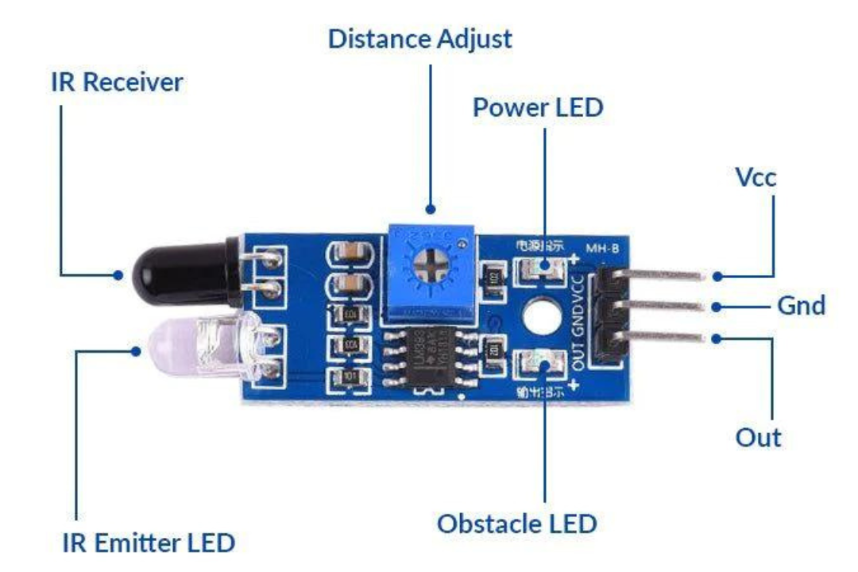
Figure 4.4 IR Sensor
As shown in Figure 4.4 IR sensor is used to detect the obstacle
4.4 RJ45 ETHERNET ADAPTER
As shown in Figure 4.5 RJ45 is a simple ethernet adapter used to provide wired network connectivity to systems that do not have native ethernet port. It converts interfaces like USB to Ethernet (RJ45), enabling communication over a LAN.
Key Components (Parts)
- RJ45 Port (8P8C Connector): Used to connect Ethernet cable to the adapter
- USB Interface / Host Connector: Connects to Laptop or Raspberry Pi (USB 2.0 / 3.0)
- Ethernet Controller Chip (NIC Controller): Handles data transmission and reception. Converts USB signals ↔ Ethernet signals
- PHY (Physical Layer Transceiver): Manages physical signal transmission over cable
- LED Indicators: Shows link status and data activity
- Internal Circuit Board: Connects all components and controls signal flow
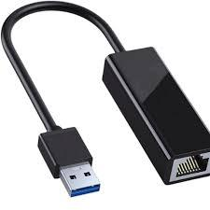
Figure 4.5 RJ45 Ethernet Adapter
How It Works
- The adapter connects to the device via USB interface
- Operating system installs driver for network interface
- Data from the device is:
- Converted from USB format → Ethernet frames
- The Ethernet controller sends data through the RJ45 port
- On receiving data:
- Ethernet signals → converted back to USB data
- Enables the device to communicate over a wired LAN network

4.5 ETHERNET SWITCH
Ethernet switch is a networking device used to connect multiple devices within a Local Area Networks. It forwards data efficiency using MAC (Media Access Control) address.
As shown in figure 4.6 key Components (Parts) are:
- Ports (RJ45 ports) – Interfaces to connect Ethernet cables
- Switching Fabric – Internal circuitry that forwards data between ports
- MAC Address Table (CAM Table) – Stores device MAC addresses
- Power Supply Unit – Provides power to the switch
- Control Logic / Processor – Manages data flow and switching decisions
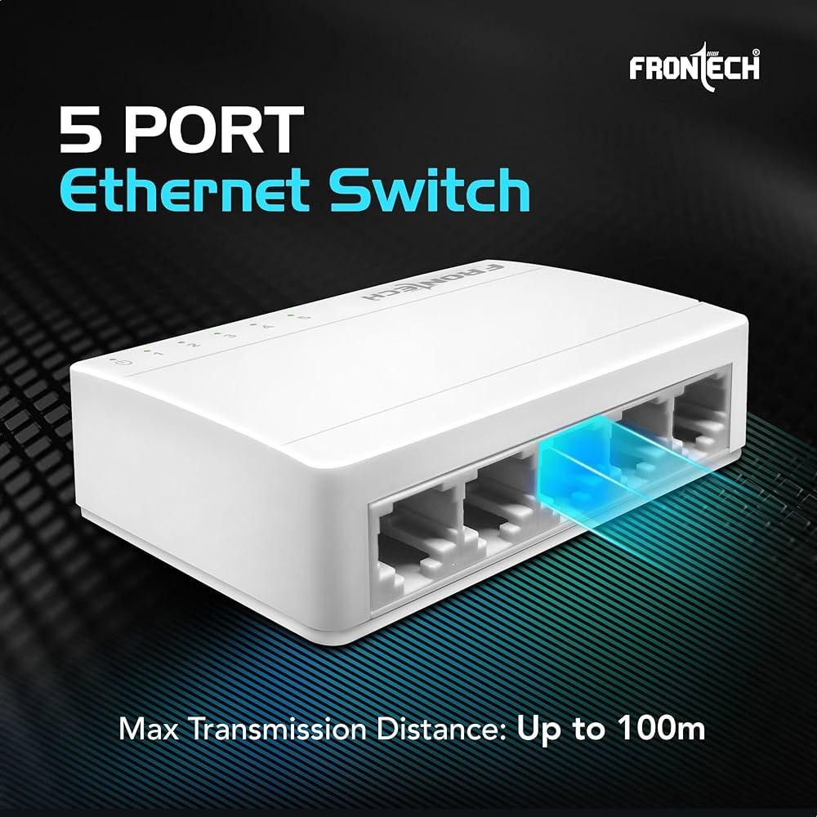
Figure 4.6 Ethernet Switch

How It Works
- Receives data frames from a connected device
- Reads the destination MAC address in the frame
- Checks its MAC table:
- If known → forwards to the specific port
- If unknown → broadcasts to all ports
- Reduces network traffic compared to hubs by sending data only where needed
  - DEVELOPMENT IDE’s
To develop the QNX-based secured communication system for autonomous vehicles, Integrated Development Environments (IDEs) are effectively used to design, implement, debug, and test both software and network communication system. This IDE helps in implementing the robust, real-time, secure system which is crucial for autonomous vehicle applications.
QNX Momentics IDE:
The most important development environment for QNX is the Momentics IDE, which provides comprehensive package for C/C++ development. The platfrom provides facility to read, write, debud, and test the code for the QNX Neutrino RTOS.
Momentics IDE integrates:
- Editor and compiler for rapid application development.
- Debugger for supervising processes and real-time execution.
- System profiler for analyzing CPU, memory, and network usage, which is crucial for performance-critical vehicle applications.

CHAPTER 5: IMPLEMENTATION
5.1 DESIGN APPROACH
The design approach of the suggested system is based on a distributed client-server model[11], where numerous autonomous vehicles communicate through a centralized yet expandable network. Raspberry Pi units represent vehicle nodes, and laptops represent processing systems. The comprehensive design ensures that data collected from multiple nodes can be competently transmitted, processed, and shared across the network. A modular design strategy is fostered to simplify future development and expansion. Each section, such as communication, sensing, and processing, is planned independently and later incorporated. This strategy refines system flexibility and allows additional functionalities to be integrated without swaying the existing structure.
By utilizing a wired Ethernet communication structure, the proposed system ensures high reliability and real-time performance. Compared to wireless alternatives, this approach reduces latency and guarantees stable data transmission, which is crucial for autonomous vehicle applications.
5.2 QNX DEPLOYMENT ON RASPBERRY PI
Implementing the proposed system requires deploying the QNX operating system on the Raspberry Pi platform. Primarily, the QNX Software Development Platform (SDP) is installed on the host system using the QNX Software Center. The installation involves logging in with a valid QNX account to access all necessary packages. Without authentication, essential components such as Board Support Packages (BSPs) will not be visible, which are important for hardware compatibility.
The BSPs installed from the QNX Software Center include the necessary drivers, startup files, and utilities required for booting QNX on Raspberry Pi hardware. The BSP file contains boot initialization scripts, device drivers for peripherals (such as Ethernet and USB), and the build configurations required to generate a bootable image. To start the operating system, a bootable image file (typically ifs-rpi4.bin) is required, which is executed by running specific build commands. A bootable SD card is prepared by formatting it in FAT32 and copying the generated image along with necessary boot files, such as bootcode.bin.
Finally, the SD card is inserted into the Raspberry Pi, and the device is powered on. Upon successful booting, the QNX operating system initializes and displays a terminal interface, ensuring a stable and reliable environment for implementing real-time communication and data processing.
5.2.1 TECHNICAL INSTALLATION OF QNX NEUTRINO RTOS ON RASPBERRY PI
Phase 1: Preparing the Environment
1.1. Obtaining QNX SDP 8.0 and Licensing
Before any hardware or network configuration, you must acquire a valid QNX SDP 8.0 license. QNX now offers a free, non-commercial single-user license, making it accessible for personal and educational projects.
Steps:
1. Create a myQNX Account:
- Visit QNX Account Registration and register for a myQNX account.
2. Request and Deploy License:
- After logging in, navigate to the QNX SDP 8.0 license request page.
- Accept the non-commercial license terms and deploy the license to your account.
3. Download QNX Software Center (QSC):
- Download the QNX Software Center from the official download page.
- Install QSC on your Windows or Linux host machine.
4. Install QNX SDP 8.0:
- Launch QSC and log in with your myQNX credentials.
- Select and install QNX SDP 8.0, which includes the OS, development tools, and runtime libraries.

Explanation:
The QNX Software Center acts as the central hub for managing QNX installations, licenses, and packages. It streamlines the process of setting up the development environment and ensures you have access to the latest BSPs and tools. The non-commercial license is suitable for evaluation, learning, and prototyping, but commercial deployment requires a separate agreement.
1.2. Installing QNX Momentics IDE
The QNX Momentics IDE, based on Eclipse, provides an integrated environment for developing, debugging, and deploying applications on QNX targets.
Steps:
1. Install Momentics IDE via QSC:
- In QSC, select "Add Installation" and choose QNX Momentics IDE.
- Follow the installation wizard to complete the setup.
2. Verify Installation:
- Launch the IDE and ensure it starts without errors.
- Optionally, install the QNX Toolkit extension for Visual Studio Code if you prefer a lighter editor.
Explanation:
Momentics IDE is essential for managing projects, building code, and interfacing with QNX targets. It provides features such as the Target Navigator, SSH terminal integration, and project management tools tailored for QNX development.
1.3. Downloading and Installing the Raspberry Pi 4 BSP
The Board Support Package (BSP) provides the necessary drivers, utilities, and configuration files to run QNX on the Raspberry Pi 4, including GPIO, I2C, SPI, and more.
Steps:
1. Install the RPi4 BSP via QSC:
- In QSC, search for "Raspberry Pi" in the package list.
- Install the "QNX SDP 8.0 BSP for Raspberry Pi BCM2711 R-Pi4" package.
2. Locate the BSP Archive:
- The BSP is typically downloaded as a ZIP file into the bsp directory of your QNX SDP installation.
3. Extract or Import the BSP:
- Command-Line Extraction:
- unzip -d bsp_working_dir BSP_raspberrypi-bcm2711-rpi4_be-800_build_ID.zip
IDE Import:
- In Momentics IDE, go to File > Import > QNX > QNX Source Package and BSP.
- Browse to the BSP ZIP archive and import it.
4. Set Environment Variables (if using CLI):
- On Linux:
- source /path/to/qnx800/qnxsdp-env.sh
- On Windows:
- call \path\to\qnx800\qnxsdp-env.bat

Explanation:
The BSP contains all the low-level support required for the RPi4 hardware, including the bcm2711-bsp library for GPIO access. Importing it into the IDE or extracting it for command-line builds prepares you for image creation and customization.
Phase 2: Flashing QNX to the Raspberry Pi 4
2.1. Downloading the Quick Start Target Image (QSTI)
QNX provides a pre-built Quick Start Target Image (QSTI) for the Raspberry Pi 4, simplifying the initial setup.
Steps:
1. Locate the QSTI Image:
- After installing the RPi4 BSP, find the .img file (e.g., qnx_sdp8.0_rpi4_quickstart_YYYYMMDD.img) in the images directory of your QNX installation.
2. Download Required Boot Files:
- Download the following files from the Raspberry Pi firmware GitHub repository:
- bcm2711-rpi-4-b.dtb
- fixup4.dat, fixup4cd.dat, fixup4db.dat, fixup4x.dat
- start4.elf, start4cd.elf, start4db.elf, start4x.elf
- Prepare a config.txt file with appropriate boot parameters.
Explanation:
The QSTI image is a ready-to-use QNX OS image for the RPi4, including essential drivers and utilities. The additional boot files are necessary for the Raspberry Pi's bootloader to recognize and load the QNX image.
2.2. Flashing the SD Card
Steps:
1. Insert the SD Card into Your Computer:
- Use a USB SD card reader.
2. Format the SD Card (if necessary):
- On Windows: Right-click the SD card in Explorer, select "Format", and choose FAT32.
- On Linux: Use gparted or mkfs.fat.
3. Flash the QNX Image:
- Using Raspberry Pi Imager or Balena Etcher:
- Select the QNX .img file and flash it to the SD card.
- Using dd (Linux):
- sudo dd if=/path/to/qnx_sdp8.0_rpi4_quickstart.img of=/dev/sdX bs=4M status=progress conv=fsync
- Replace /dev/sdX with your SD card device.
4. Copy Boot Files:
- After flashing, mount the SD card's boot partition and copy the downloaded boot files and config.txt to the root of the partition.
Explanation:
Flashing the image and copying the necessary boot files ensures the RPi4 can boot QNX successfully. The config.txt file should specify the kernel image (e.g., kernel=ifs-rpi4.bin) and other boot parameters as needed.
2.3. (Optional) Setting Static IP and Hostname Before First Boot
For headless setups or to ensure consistent network access, you can pre-configure the RPi4's network settings by editing files on the SD card's /boot partition.
Steps:
1. Edit /boot/network:
- Add the following lines (adjust as needed):
- HOSTNAME=qnxpi
- IP_ADDR=10.10.10.10
2. (Optional) Edit qnx_config.txt for Wi-Fi:
- Add Wi-Fi credentials if using wireless.
Explanation:
Setting a static IP and hostname at this stage simplifies subsequent SSH and IDE connections, especially in environments without DHCP.
5.3 HARDWARE INTEGRATION
Hardware integration in this project involves connecting sensors to a Raspberry Pi, linking the Raspberry Pi and a laptop via RJ45 cables, and using an Ethernet switch.
Sensors are connected to the Raspberry Pi using GPIO pins, allowing for real-time data collection. The Raspberry Pi processes the raw data before transmitting it to the network.
To facilitate communication, RJ45 Ethernet cables connect both the laptop and the Raspberry Pi to the switch, providing a physical interface for networking.
An Ethernet switch is utilized to integrate the Raspberry Pi and laptop, forming a Local Area Network (LAN) where data can be transmitted effectively between nodes.
An efficient power supply and secure physical connections are ensured for all components to maintain system stability. The setup is arranged in an organized manner to minimize signal loss and ensure reliable operation during continuous data transmission.
5.3.1 PROCEDURE FOR HARDWARE SETUP
Phase 3: Hardware and Network Setup
3.1. Connecting the Raspberry Pi 4 to the Laptop via Ethernet
A direct Ethernet connection (no DHCP) between your Windows laptop and the RPi4 requires manual IP configuration on both ends.
Steps:
1. Connect the Ethernet Cable:
- Plug one end into the RPi4 and the other into your laptop.
2. Power the RPi4:
- Use the official 5V USB-C power supply.
3. (Optional) Connect Serial Console for Debugging:
- Use a USB-TTL serial cable:
- J8 pin 6: GND
- J8 pin 8: UART_TXD0
- J8 pin 10: UART_RXD0
- Connect to your PC and use Windows
Explanation:
A direct Ethernet link is ideal for isolated development, ensuring no IP conflicts and consistent connectivity. The serial console is invaluable for troubleshooting boot issues or headless operation.
5.4 NETWORK SETUP
This setup is based on a wired LAN configuration where all devices are connected to an Ethernet switch. To enable proper identification and communication, each device is assigned a unique IP address within the same subnet. Setting up IP addresses and subnet masks is part of the network configuration to verify connectivity between nodes. Ping commands are essential to ensure that all devices are reachable within the network. Using ping commands, we can confirm that the communication path between clients and servers is correctly established. Ethernet-based communication offers low packet loss and high-speed data transfer. To ensure reliable, real-time data exchange, this technology provides a secure and stable connection.
5.4.1 SETTING UP THE NETWORK CONFIGURATIONS
Phase 4: Configuration of network settings
4.1. Configuring Static IP on Windows (Laptop Side)
Steps:
1. Open Network Connections:
- Press Win + R, type ncpa.cpl, and press Enter.
2. Identify the Ethernet Adapter:
- Right-click the relevant adapter (usually labeled "Ethernet" or similar).
3. Set Static IP:
- Select "Properties".
- Double-click "Internet Protocol Version 4 (TCP/IPv4)".
- Choose "Use the following IP address".
- For RPI 1:
- IP address: 10.10.10.10
- Subnet mask: 255.255.255.0
- For RPI 2:
- IP address: 10.0.0.11
- Subnet mask: 255.255.255.0
- Leave "Default gateway" and "DNS server" blank or as appropriate.
4. Click OK and Close All Dialogs.
Explanation:
Assigning a static IP ensures the laptop and RPi4 are on the same subnet and can communicate directly. The chosen IPs should not conflict with other devices on your network.
4.2. Configuring Static IP on Raspberry Pi 4 (QNX Side)
Steps:
1. Boot the RPi4 with the QNX SD Card Inserted.
2. Access the QNX Terminal:
Via HDMI/keyboard, serial console, or SSH (if already configured).
3. Login as qnxuser (default password: qnxuser).
4. Switch to Root:
5. su -
- Enter password: root (if set; otherwise, use qnxuser if root password is not set).
6. Configure the Ethernet Interface:
- For RPI 1:
- ifconfig genet0 10.10.10.10 netmask 255.255.255.0 up
- For RPI 2:
- ifconfig genet0 10.0.0.11 netmask 255.255.255.0 up
Explanation:
The ifconfig command assigns the static IP and brings up the Ethernet interface. The genet0 interface is the default Ethernet device on the RPi4 under QNX.

5.5 QNX TARGET SETUP AND GPIO ACCESS
This section outlines establishing communication between the QNX Momentics IDE and a Raspberry Pi 4 to verify and access the GPIO interface. The target is configured in the IDE using its static IP for remote debugging and file transfer via the Target Navigator. After securing SSH access, root-level, privileged access is established for hardware operations. GPIO functionality is managed through QNX resource managers (gpio-bcm2711) and the rpi_gpio Python module, allowing command-line and programmatic pin control. Proper operation is verified, and the on utility is used for secure, privileged execution. This phase ensures successful development environment-to-hardware integration for external peripheral interaction.
Phase 5: Connecting QNX Momentics IDE to the Raspberry Pi 4
5.1. Setting Up the Target in Momentics IDE
Steps:
1. Open QNX Momentics IDE.
2. Open Target Navigator:
- Navigate to Window > Show View > Target Navigator.
3. Add a New QNX Target:
- Click the "+" icon or select "Add new QNX Target Connection".
- Enter the static IP address of your RPi4 (e.g., 10.10.10.10).
4. Verify Connection:
- The IDE should indicate a successful connection.
- If prompted, ensure the qconn agent is running on the target (usually started by default in QSTI images).
Explanation:
The Target Navigator manages connections to physical and virtual QNX targets, enabling file transfers, remote debugging, and terminal access.
5.2. Opening an SSH Terminal to the Target
Steps:
1. In Target Navigator, Right-Click the Connected Target.
2. Select "Open SSH Terminal".
3. Login as qnxuser:
- Username: qnxuser
- Password: qnxuser
4. You should see a shell prompt ($).
Explanation:
SSH access provides a secure, interactive shell on the target, essential for running commands, transferring files, and troubleshooting.
5.3. Switching to Root User
Steps:
1. At the qnxuser prompt, type:
2. su -
3. Enter the root password (commonly root or as set during image creation).
4. If prompted for a username, type:
5. root
6. Upon success, the prompt changes from $ to #, indicating root access.
Explanation:
Root privileges are required for GPIO access and certain system-level operations. The su - command initiates a login shell as root, loading the root environment and profile.

Phase 6: Verifying and Accessing GPIO
6.1. Understanding the GPIO Access Model on QNX
GPIO access on the RPi4 under QNX is managed by the bcm2711-bsp library and associated utilities. Access is typically restricted to the root user for security reasons. The gpio-bcm2711 utility provides command-line access to GPIO pins, while the rpi_gpio Python module enables programmatic control.
Key Utilities and Libraries:
• gpio-bcm2711: Command-line utility for reading/writing GPIO.
• bcm2711-bsp: Board Support Package library for the RPi4 SoC.
• rpi_gpio: Python module for GPIO access.
• on: QNX utility to execute commands as another user or on another node.
Explanation:
The combination of these tools allows both interactive and programmatic manipulation of GPIO pins, supporting a wide range of applications from simple LED blinking to complex sensor interfacing.
6.2. Checking GPIO Resource Managers
Before accessing GPIO, ensure the necessary resource managers are running:
Commands:
pidin -p "rpi_gpio" ar
pidin -p "i2c-bcm2711" ar
pidin -p "spi-bcm2711" ar
Expected Output:
• Each command should list the corresponding process if running.
Explanation:
Resource managers handle hardware access and multiplexing. If any are missing, GPIO, I2C, or SPI operations may fail. Restart or reconfigure as needed.
6.3. Using the gpio-bcm2711 Utility
Syntax:
gpio-bcm2711 get|set|funcs [gpio number] [options]
Examples:
• Read the state of all GPIOs:
• gpio-bcm2711 get
• Read GPIO17:
• gpio-bcm2711 get 17
• Set GPIO20 as output and drive high:
• gpio-bcm2711 set 20 op dh
• Set GPIO20 as input with pull-down:
• gpio-bcm2711 set 20 ip pd
Explanation:
The utility supports batch operations, alternate functions, and pull-up/down configuration. Refer to the official documentation for a full list of options.
6.4. Accessing GPIO as Root via the on Utility
In QNX, the on utility allows you to execute commands as another user or with elevated privileges. To access GPIO as root:
Command:
on -u 0 gpio-bcm2711 get 17

Explanation:
• on -u 0 runs the command as user ID 0 (root).
• This is necessary because direct GPIO access is restricted to root for security.
Continuous Sensor Data Logging:
To record sensor data every second:
while true; do on -u 0 gpio-bcm2711 get 17; sleep 1; done
Explanation:
This shell loop continuously reads GPIO17 every second, suitable for basic data logging or sensor monitoring.
Explanation:
The API closely mirrors the popular RPi.GPIO module on Linux, supporting input/output, event detection, PWM, SPI, and I2C.
5.6 CODE STRUCTURE AND DESIGN
This prototype utilizes a client–server architecture to facilitate real-time vehicle-to-vehicle (V2V) communication. Each vehicle operates as a server on a Raspberry Pi, continuously broadcasting live sensor data via TCP sockets to ensure reliable transmission. A centralized client simultaneously interfaces with multiple vehicle servers to aggregate data for monitoring and analysis.The system integrates an IR sensor for obstacle detection and an ultrasonic sensor for distance measurement. By evaluating real-time proximity data, the system executes automated decision-making to categorize safety levels as “SAFE,” “HIGH RISK,” or “COLLISION IMMINENT.” This architecture provides a robust framework for continuous data exchange and proactive accident prevention.
5.6.2 SERVER CODE:
#include <stdio.h>
#include <stdlib.h>
#include <string.h>
#include <unistd.h>
#include <time.h>
#include <arpa/inet.h>
#include <sys/socket.h>
#include <pthread.h>
#define PORT 6500
#define VEHICLE_ID "CAR_1" //similarly CAR_2 for second Pi
typedef struct {
char vehicle_id[16];
int ir;
float distance;
char status[16];
long timestamp;
} vehicle_data_t;
// -------- SENSOR SIMULATION --------
int read_ir() {
FILE *fp;
char buffer[128];
fp = popen("on -u 0 gpio-bcm2711 get 17", "r");
if (!fp) return 0;
if (fgets(buffer, sizeof(buffer), fp) == NULL) {
pclose(fp);
return 0;
}
pclose(fp);
return strstr(buffer, "level=0") ? 1 : 0;
}
float read_ultrasonic() {
return 10 + rand() % 90;
}
const char* get_status(float d) {
if (d < 20) return "TOO CLOSE";
else if (d < 50) return "CAUTION";
else return "CLEAR";
}
// -------- CLIENT THREAD --------
void* handle_client(void* arg) {
int client_fd = *(int*)arg;
free(arg);
while (1) {
vehicle_data_t data;
data.ir = read_ir();
data.distance = read_ultrasonic();
strcpy(data.vehicle_id, VEHICLE_ID);
strcpy(data.status, get_status(data.distance));
data.timestamp = time(NULL);
int n = send(client_fd, &data, sizeof(data), 0);

if (n <= 0) {
printf("Client disconnected\n");
break;
}

usleep(500000);
}
close(client_fd);
return NULL;
}
// -------- MAIN --------
int main() {
srand(time(NULL));
int server_fd;
struct sockaddr_in addr;
server_fd = socket(AF_INET, SOCK_STREAM, 0);
addr.sin_family = AF_INET;
addr.sin_port = htons(PORT);
addr.sin_addr.s_addr = INADDR_ANY;
bind(server_fd, (struct sockaddr*)&addr, sizeof(addr));
listen(server_fd, 5);
printf("Server %s running...\n", VEHICLE_ID);
while (1) {
int *client_fd = malloc(sizeof(int));
*client_fd = accept(server_fd, NULL, NULL);
if (*client_fd < 0) continue;
printf("Client connected\n");
pthread_t tid;
pthread_create(&tid, NULL, handle_client, client_fd);
pthread_detach(tid); // auto cleanup
}
return 0;
}

A TCP server application, developed for the QNX operating system, manages real-time sensor data acquisition and transmission to a connected client. The server binds a socket, accepts client connections, and continuously loops to read IR data via system commands and simulate ultrasonic distance measurements. It structures data—including vehicle ID, safety status, and timestamps—sending it to the client for real-time monitoring.
5.6.3 CLIENT CODE:
#include <stdio.h>
#include <stdlib.h>
#include <string.h>
#include <unistd.h>
#include <arpa/inet.h>
#include <sys/socket.h>
#include <sys/select.h>
#include <math.h>
#define PORT 6500
typedef struct {
char vehicle_id[16];
int ir;
float distance;
char status[16];
long timestamp;
} vehicle_data_t;
int recv_full(int sock, void *buffer, size_t size) {
size_t total = 0;
int n;
while (total < size) {
n = recv(sock, (char*)buffer + total, size - total, 0);
if (n <= 0)
return -1;
total += n;
}
return total;
}
// -------- COLLISION --------
const char* collision_warning(float d1, float d2) {
float diff = fabs(d1 - d2);
if (diff < 10)
return "🟧COLLISION IMMINENT";
else if (diff < 30)
return "🟥HIGH RISK";
else
return "🟩SAFE";
}
int connect_to_server(char *ip) {
int sock;
struct sockaddr_in server;
sock = socket(AF_INET, SOCK_STREAM, 0);
server.sin_family = AF_INET;
server.sin_port = htons(PORT);
inet_pton(AF_INET, ip, &server.sin_addr);
if (connect(sock, (struct sockaddr*)&server, sizeof(server)) < 0) {
perror("connect failed");
exit(1);
}
printf("Connected to %s\n", ip);
return sock;
}
// -------- MAIN --------
int main() {
int sock1 = connect_to_server("10.0.0.1"); // CAR_1 RPI
int sock2 = connect_to_server("10.0.0.2"); // CAR_2 RPI
vehicle_data_t car1 = {0}, car2 = {0};
fd_set readfds;
struct timeval timeout;
int maxfd = (sock1 > sock2 ? sock1 : sock2) + 1;
while (1) {
FD_ZERO(&readfds);
FD_SET(sock1, &readfds);
FD_SET(sock2, &readfds);
timeout.tv_sec = 2;
timeout.tv_usec = 0;
int activity = select(maxfd, &readfds, NULL, NULL, &timeout);
if (activity <= 0) continue;
if (FD_ISSET(sock1, &readfds)) {
if (recv_full(sock1, &car1, sizeof(car1)) < 0) break;
}
if (FD_ISSET(sock2, &readfds)) {
if (recv_full(sock2, &car2, sizeof(car2)) < 0) break;
}
printf("\033[2J\033[H");
printf(" CAR 1 (%s)\n", car1.vehicle_id);
printf("IR : %s\n", car1.ir ? "OBSTACLE" : "CLEAR");
printf("Distance : %.2f cm\n", car1.distance);
printf("Status : %s\n\n", car1.status);
printf("CAR 2 (%s)\n", car2.vehicle_id);
printf("IR : %s\n", car2.ir ? "OBSTACLE" : "CLEAR");
printf("Distance : %.2f cm\n", car2.distance);
printf("Status : %s\n\n", car2.status);
printf("=====================================\n");
printf("⚡ COLLISION ANALYSIS\n");
printf(" %s\n", collision_warning(car1.distance, car2.distance));
printf("=====================================\n");
usleep(300000);
}
close(sock1);
close(sock2);
return 0;
}
5.6.4 MAKEFILE:
CC=qcc
CFLAGS=-Wall
LDFLAGS=-lsocket
TARGET=-Vgcc_ntoaarch64le
SRC_DIR=src
all: server client
server: $(SRC_DIR)/server.c
$(CC) $(TARGET) $(CFLAGS) $(SRC_DIR)/server.c -o server $(LDFLAGS)
client: $(SRC_DIR)/client.c
$(CC) $(TARGET) $(CFLAGS) $(SRC_DIR)/client.c -o client $(LDFLAGS)
clean:
rm -f server client
The client program is designed to receive and process data from multiple server nodes (vehicles) by establishing TCP connections with two distinct servers via their IP addresses. To handle concurrent data streams without blocking execution, the select() system call is utilized to efficiently monitor multiple sockets. Incoming data from each server is stored in dedicated structures and displayed in a formatted manner for clear interpretation. Furthermore, the client implements collision detection logic by comparing the distance values of the two vehicles. Based on this analysis, the system generates risk-level warnings, enabling real-time monitoring and informed decision-making
5.7 SYSTEM INTEGRATION PROCESS
This final process involves integrating all hardware and software components into a unified framework. This step includes connecting sensors, Raspberry Pi modules, the Ethernet switch, and the laptop systems together to work as a whole system. Integration is carried out in stages, from connecting sensors to connecting the two laptops with the Raspberry Pi via the Ethernet switch. Each detailed step helps in identifying any errors in this process and checking the smooth operation of all devices.
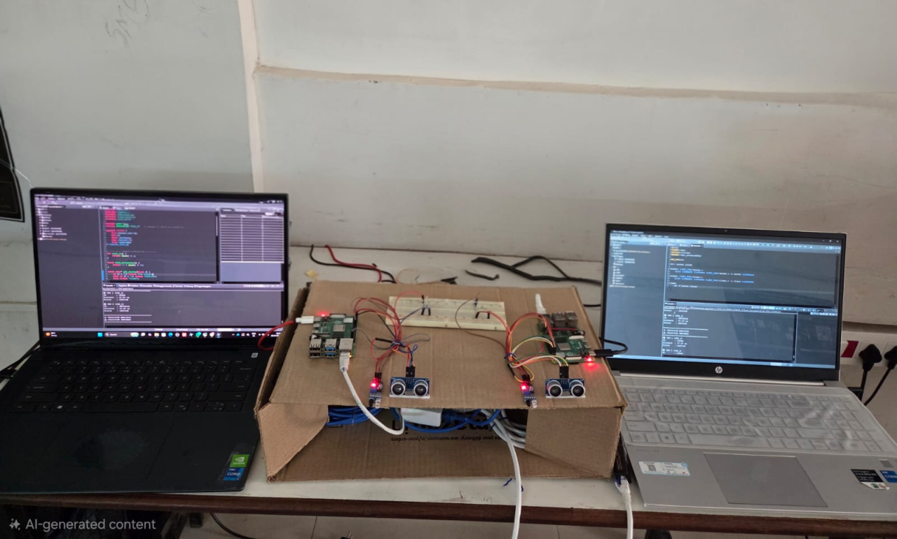
Figure 5.1 Hardware Setup
Finally, the whole system is tested for end-to-end communication between the client and server, and then from one system to another. This integrated setup enables efficient, reliable, and synchronized communication between autonomous vehicle nodes.

CHAPTER 6: TESTING AND VALIDATION
6.1 TEST PLAN DESIGN
The test plan for the defined system employs a bottom-up approach, starting with individual components and progressing to the fully integrated system. Each system component is carefully designed, with a robust communication framework established between the two autonomous vehicle nodes. The system architecture involves multiple stages of data transfer, beginning with sensors connected to a Raspberry Pi, proceeding through network communication via Ethernet adapters, and culminating in data exchange between laptop systems through an Ethernet switch. Consequently, the testing approach is organized in a phased, step-by-step process to validate each stage of the data flow independently, as well as within the fully integrated environment[17].
The primary testing phase focuses on data acquisition, where in real-time data from sensors interfaced with the Raspberry Pi is verified. This involves executing C code within the QNX Momentics environment to simulate obstacle detection and distance measurement. Subsequently, data transmission from the Raspberry Pi to the server system is validated using a wired RJ45 Ethernet connection. Upon confirming successful data acquisition, the secondary testing phase proceeds to verify data exchange protocols between two vehicle nodes.
Testing the data exchange between systems constitutes the final phase of system validation. This is achieved by implementing an Ethernet switch to establish a robust communication network between vehicle nodes. The primary objective is verified through bidirectional data exchange between laptops, ensuring seamless synchronization, sharing, and accessibility of information across multiple nodes. This rigorous testing approach validates that the entire system functions consistently, meeting the required criteria for reliable, real-time data communication.
6.2 FUNTIONAL VERIFICATION
Functional verification was conducted to ensure that each system component operates accurately and contributes effectively to the overall system performance. The verification process commenced with individual sensor testing to confirm the accurate acquisition of physical parameters. Subsequently, the Raspberry Pi was assessed for its capability to interface with the sensors, read data, and convert it into a suitable format for transmission.
Upon verification of the data acquisition process, the focus shifts to establishing communication between the Raspberry Pi and the laptop. The Ethernet adapter acts as a critical interface, ensuring reliable data transmission. This functional verification ensures the accurate reception of data by the laptop from the Raspberry Pi. To facilitate seamless connectivity, the network configuration—including IP addresses and communication ports—is validated.
Further verification was conducted to validate the interaction between two laptop systems connected via an Ethernet switch. In this setup, each laptop receives sensor data from its respective Raspberry Pi, which is then exchanged with the other system. This process was designed to simulate vehicular environmental awareness, specifically to prevent accidents during scenarios such as lane changes, U-turns, or overtaking, where real-time, surrounding environmental data is crucial for autonomous decision-making. Through this prototype, we demonstrate that safe, inter-vehicular communication can be established. The laptop systems act as servers, ensuring secure data recording and synchronized data exchange, while each system operates independently. The successful completion of these tests confirms that all system components are functioning as expected.
6.3 COMMUNICATION REALIBILITY TESTING
Communication constitutes the most critical aspect of this project, as it enables the exchange of information necessary for vehicle nodes to make autonomous decisions. The network's consistency, stability, and reliability are directly determined by the effectiveness of this communication. Given that safe, autonomous operation requires continuous and accurate real-time data exchange, system reliability is paramount. Therefore, rigorous testing will be conducted, involving the continuous transmission and reception of real-time data to evaluate communication channel performance.
Key performance parameters—including data loss, transmission delay, and connection stability—are closely monitored via network adapters and switches to ensure seamless communication. These components are rigorously tested under varying conditions to verify functionality. By utilizing Ethernet, the proposed system provides superior stability compared to wireless alternatives, guaranteeing minimal packet loss and low latency. Furthermore, repeated test cycles are implemented to ensure consistent, stable, and uninterrupted communication.
Reliability testing was conducted to evaluate data exchange between two laptop systems, in addition to the Raspberry Pi-to-laptop communication. The laptops engaged in continuous, bidirectional data transfer through an Ethernet switch for a prolonged period. The testing confirmed that the system maintains stable communication under continuous operation without degradation in performance[12].

CHAPTER 7: RESULTS AND DISCUSSIONS
7.1 EXPERIMENTAL OUTPUT ANALYSIS
The experimental output analysis focuses on evaluating the data generated from sensors connected to Raspberry Pi nodes and the successful transmission of this data to the laptop systems through Ethernet communication. The collected data from the sensors is sent to the serevr system using the client-server mechanism and with the help of RJ45 Ethernet adapter. The received data is displayed on the console of the QNX Momentics IDE.
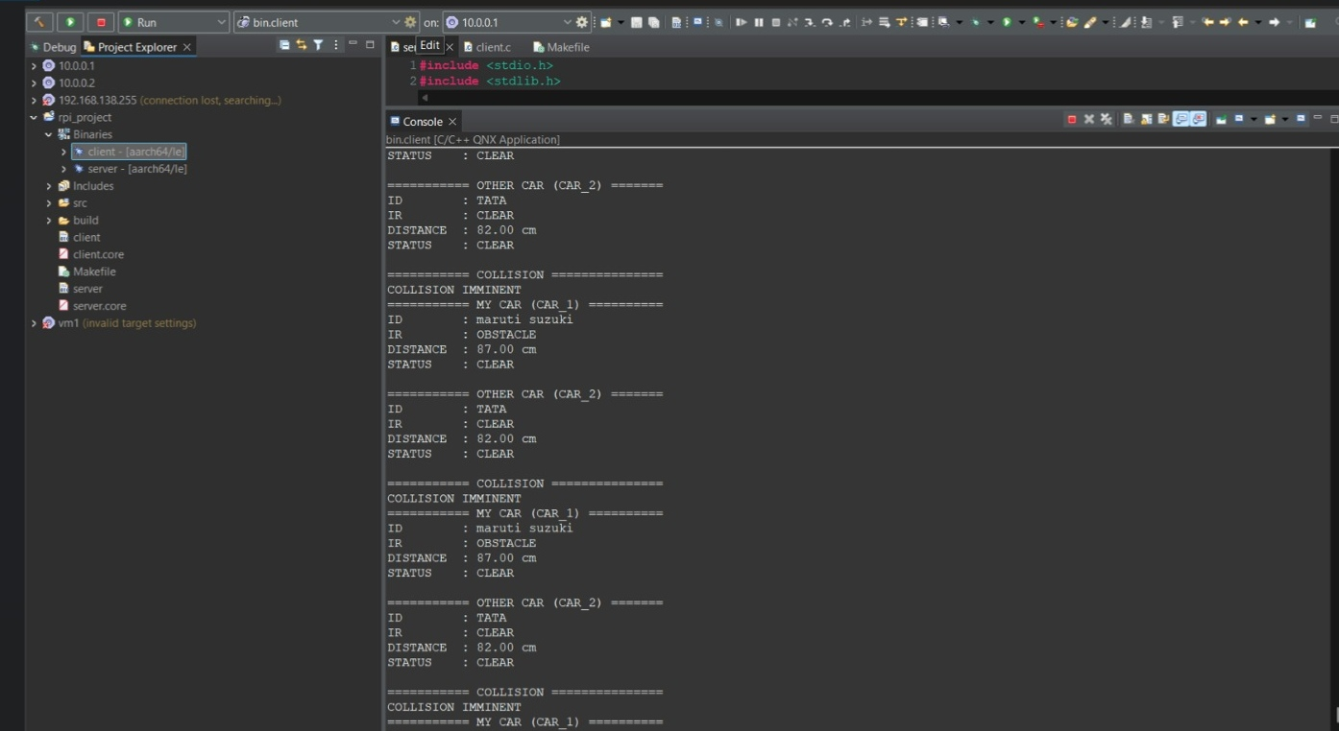
Figure 7.1 Console Output
The output is displayed as shown in Figure 7.1.
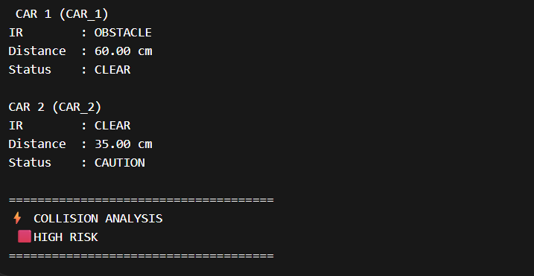
Figure 7.2 Output Instance 1
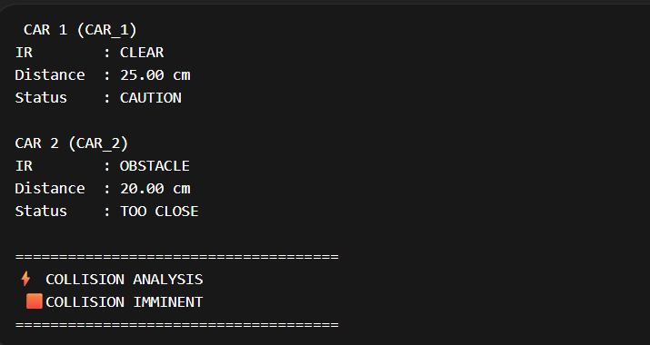
Figure 7.3 Output Instance 2
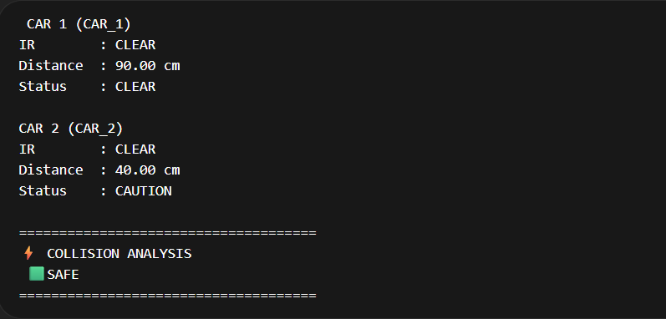
Figure 7.4 Output Instance 3
Different output instances are shown in Figures 7.2, 7.3, and 7.4.
The console results confirm that the system successfully receives, processes, and transmits real-time data to the secondary server, ensuring accurate bidirectional communication in every cycle[12]. Data exchange is achieved seamlessly and with low latency via Ethernet. The QNX Neutrino RTOS demonstrated excellent performance in managing the process, while the Raspberry Pi facilitated real-time data acquisition via GPIO access. The GPIO interfacing, implemented within the QNX environment through direct commands, ensures efficient sensor data acquisition. The output displayed on both workstations was consistent, clear, and transmitted without delay.
7.2 PERFORMANCE EVALUATION
The performance of the developed system was rigorously evaluated based on key performance indicators (KPIs), including data transmission speed, communication latency, and overall reliability. Utilizing a wired Ethernet infrastructure through a centralized Ethernet switch, the system achieved high-speed data transfer rates with negligible packet loss, ensuring data integrity.
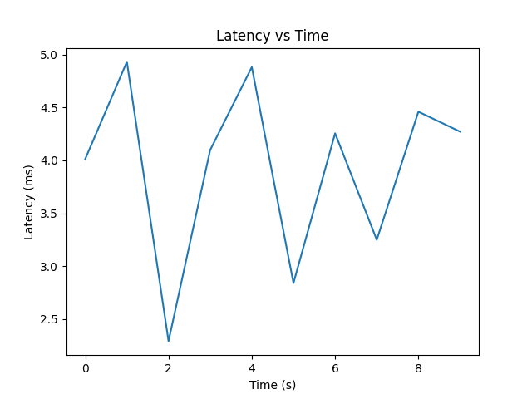
Figure 7.5 Latency Graph
Figure 7.5 shows, the latency graph demonstrates a consistently low time delay during data transmission between the Raspberry Pi and the laptop. These results validate the high efficiency of Ethernet-based communication, ensuring the minimal latency required for real-time data exchange in autonomous vehicle systems.
Communication stability was validated through continuous data exchange between the Raspberry Pi and the terminal laptop, as well as between peer laptops, exhibiting high reliability and consistent performance. Latency, defined as the temporal delay between data generation at the sensor node and final reception at the monitoring laptop, was measured to be exceptionally low, confirming the system's suitability for real-time application requirements. Furthermore, extensive endurance testing conducted under continuous, high-volume data transmission conditions confirmed that the system maintains robust performance with no significant degradation over time.
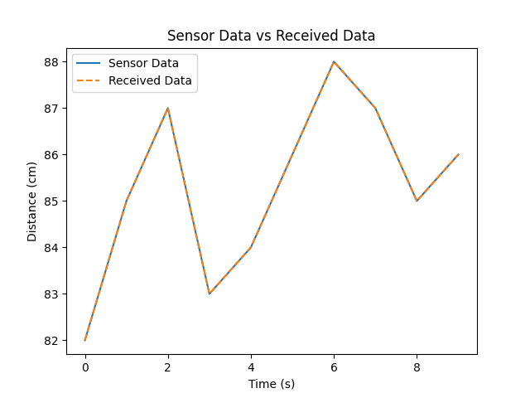
Figure 7.6 Data accuracy graph
The transmitted data from the Raspberry Pi to the laptop was evaluated to ensure integrity. The results indicate a perfect correlation between the sent and received data, validating the accuracy of the communication system.
7.3 OBSERVATIONAL STUDY
During the implementation and testing phases, comprehensive observations were documented regarding the system's behavior, communication reliability, and overall performance. A primary finding indicated that the Ethernet-based network infrastructure provided superior stability and a robust, interference-free environment compared to alternative wireless communication technologies. The utilization of RJ45 Ethernet adapters facilitated seamless device connectivity, eliminating potential configuration complexities and establishing a direct, reliable physical link.
Furthermore, testing verified the system’s capacity for efficient, bidirectional communication between the two laptop systems. Data transmission from the Raspberry Pi node was successfully achieved, with the data seamlessly received and processed by the secondary laptop, demonstrating effective data integrity across the network. Synchronization between the nodes remained consistent throughout operation, with no observed data latency or inconsistency.
Long-duration, continuous data transmission tests were conducted to evaluate system robustness. The system demonstrated high resilience, operating efficiently over prolonged periods without experiencing system crashes or communication failures. Consequently, these findings validate the proposed system's suitability for real-time, high-reliability applications.
Key Observation points
- Stable wired communication with no signal loss
- Accurate data transmission without corruption
- Smooth data exchange between laptops
- Low latency and high reliability
- System remains stable under continuous operation
7.4 COMPARATIVE ANALYSIS
The proposed system is evaluated against conventional communication paradigms, with a specific focus on wireless-based architectures. This comparative analysis underscores the significant advantages inherent in Ethernet-based communication, particularly regarding enhanced reliability, superior data transmission speeds, and robust security protocols. In contrast to wireless communication, which is often susceptible to environmental interference, signal attenuation, and unpredictable fluctuations, the implemented Ethernet infrastructure provides a dedicated, shielded transmission medium, ensuring consistent and deterministic performance[19].
Regarding data accuracy, the proposed system demonstrates superior operational integrity, characterized by an absence of data loss or corruption during transmission. Furthermore, the integration of an Ethernet switch enables efficient management of multiple nodes, facilitating scalable and reliable communication between interconnected vehicle units. These attributes render the system highly suitable for critical applications requiring high-fidelity, real-time data exchange.

CHAPTER 8: FUTURE SCOPE AND CONCLUSION
8.1 SCOPE FOR ENHANCEMENT
While the proposed system establishes a robust Ethernet-based framework for real-time data exchange among autonomous vehicle nodes, significant potential exists to enhance its scalability, flexibility, and operational applicability. Primarily, transitioning from wired connections to wireless communication technologies, such as 5G or advanced Wi-Fi protocols, is essential to accommodate the dynamic nature of real-world autonomous vehicular environments. Furthermore, integrating cloud-based architecture will enable high-volume sensor data storage, facilitating comprehensive remote analytics, predictive maintenance, expanded, long-range communication capabilities beyond the limitations of a local network.
To ensure operational security and safety in V2X (Vehicle-to-Everything) scenarios, the implementation of sophisticated encryption protocols and cryptographic authentication methods is necessary. Furthermore, embedding artificial intelligence and machine learning algorithms into the communication pipeline will enhance the system's ability to analyze data in real time, enabling predictive collision avoidance and autonomous decision-making. These enhancements will not only improve the system's overall efficiency but will also accelerate its transition from a simulated framework to a practical, secure, and intelligent solution for autonomous vehicle ecosystems.
8.2 SYSTEM IMPROVEMENTS
While the current implementation ensures reliable node-to-node communication, future iterations will focus on optimizing system performance, usability, and scalability. Key improvements include developing a graphical user interface (GUI) for real-time data visualization, alerts, and system diagnostics, moving beyond terminal-based output. To handle higher data volumes and multiple vehicle nodes, we will implement advanced messaging protocols (e.g., MQTT or optimized DDS) to reduce latency and enhance data prioritization. Furthermore, hardware enhancements, such as upgrading to higher-precision sensors and more robust processors (e.g., Raspberry Pi 5 or microcontrollers like ESP32), will improve data acquisition and processing efficiency. Finally, upgrading the physical layout and cable management will enhance overall structural stability and reduce potential failures.
Although the current system achieves reliable communication between nodes, several optimizations are proposed to enhance performance, usability, and scalability. These improvements are designed to transition the prototype into a more robust and efficient system.
- GUI Development and Visualization: To improve monitoring capability, a graphical user interface (GUI) will be developed. This interface will replace terminal-based outputs, providing real-time dashboards, visualized system metrics, and intuitive status alerts.
- Advanced Communication Protocols: To manage larger datasets and a higher density of vehicle nodes, the communication protocol will be upgraded. Implementing efficient message queuing systems (e.g., MQTT) will ensure reduced latency, better data prioritization, and increased throughput, which is vital for scalability.
- Hardware Enhancement: To increase data acquisition rates and processing speed, the system will be upgraded with high-precision sensors and more powerful processing units, such as migrating to the latest Raspberry Pi generation or integrating specialized microcontroller nodes.
- System Stability and Cable Management: A complete overhaul of the hardware layout will be implemented to improve reliability. Professional cable management and enhanced component shielding will reduce potential points of failure and enhance overall system endurance in dynamic environment.
8.3 SUMMARY OF CONTRIBUTIONS
This project presents the design and implementation of a robust communication system for autonomous vehicle nodes, utilizing a client-server architecture to establish real-time data exchange via an Ethernet network. By integrating Raspberry Pi modules, onboard sensors, and laptop-based processing units through RJ45 Ethernet adapters and a centralized switch, the system ensures stable, low-latency, and secure communication. A key contribution is the development of a multi-node framework that enables effective bidirectional data transmission, processing, and synchronization between vehicle systems.
The implementation, validated through testing on two laptop systems, demonstrates seamless coordination and robust performance, providing a solid foundation for future autonomous vehicle research. Combining advanced embedded systems with networking principles, this project addresses real-world communication challenges with high accuracy and efficiency.
8.4 FINAL REMARKS
In conclusion, the proposed system successfully establishes robust, Ethernet-based communication between autonomous vehicle nodes, meeting all primary project objectives. The seamless integration of hardware and software components enables efficient real-time data acquisition, processing, and transmission. By utilizing a wired communication framework, the system delivers the high reliability, minimal latency, and precise data exchange required for autonomous operations.
Experimental results and performance analysis validate that the system functions effectively under diverse conditions, demonstrating consistent communication with negligible data loss. Furthermore, the successful data exchange between multiple nodes highlights the system’s adaptability for scalable and distributed applications.
Overall, this project constitutes a significant advancement in the development of communication infrastructure for autonomous vehicles[3]. With further refinements, this system holds strong potential for deployment in real-world scenarios, contributing to enhanced safety and efficiency in future transportation systems.

AUTHOR’S PUBLICATIONS
The following paper based on this project has been submitted for publication:
[1] A. N. S. L. Revathi, P. Hari Chandana and Ch. Kavya Sri,
“QNX RTOS-Based Secured Communication Gateway for Autonomous Vehicles,”
submitted to International Conference on Electronic Systems and Artificial Intelligence Applications (ICESAIA-2026), Methodist College of Engineering & Technology, Hyderabad, India.

REFERENCES
[1] QNX Software Systems, “QNX Neutrino RTOS System Architecture,” White Paper, 2023. [Online]. Available: https://blackberry.qnx.com
[2] K. Koscher et al., “Experimental Security Analysis of a Modern Automobile,” in Proc. IEEE Symp. Security and Privacy, 2010.
[3] S. Checkoway et al., “Comprehensive Experimental Analyses of Automotive Attack Surfaces,” in Proc. USENIX Security Symp., 2011.
[4] AUTOSAR Consortium, “AUTOSAR Architecture Specification,” 2022. [Online]. Available: https://www.autosar.org
[5] ISO 26262, “Road Vehicles – Functional Safety,” International Standard, 2018.
[6] IEEE 802.3 Standard, “Ethernet Communication Protocol,” IEEE, 2022. [Online]. Available: https://standards.ieee.org
[7] M. Wolf, Security Engineering for Automotive Systems. Springer, 2017.
[8] J. Petit and S. Shladover, “Potential Cyberattacks on Automated Vehicles,” IEEE Trans. Intell. Transp. Syst., 2015.
[9] NXP Semiconductors, “Automotive Ethernet Overview,” Application Note, 2021. [Online]. Available: https://www.nxp.com
[10] R. Bosch GmbH, “CAN Specification Version 2.0,” 1991.
[11] M. Wolf, A. Weimerskirch, and T. Wollinger, “State of the Art: Embedding Security in Vehicles,” EURASIP Journal on Embedded Systems, 2007.
[12] A. Greenberg, “Hackers Remotely Kill a Jeep on the Highway,” Wired Magazine, 2015. [Online]. Available: https://www.wired.com
[13] SAE International, “Taxonomy and Definitions for Terms Related to Driving Automation Systems,” 2021. [Online]. Available: https://www.sae.org
[14] P. Koopman and M. Wagner, “Autonomous Vehicle Safety: An Interdisciplinary Challenge,” IEEE Intell. Transp. Syst. Mag., 2017.
[15] QNX Documentation, “Inter-process Communication in QNX Neutrino,” 2023. [Online]. Available: https://blackberry.qnx.com

